NAME: GANZA Jules
ID:25110
INDIVIDUAL ASSIGNMENT I: SQL JOINS & WINDOW FUNCTIONS PROJECT

SQL JOINs and Window Functions Project Documentation

- Tool Used: MySQL Workbench

1. Business Scenario
The business I choose is a small online retail store that sells everyday household items such as kitchen tools, cleaning supplies, and small electronics. The Sales and Marketing department needs help understanding how customers are buying products and which items perform the best.
The main problem is that the company has a lot of transaction data, but it is not organized in a way that helps them see trends over time. They cannot easily tell which products sell the most, how often customers buy, or whether monthly sales are going up or down.
The insights the business wants include:
- Which products bring in the most revenue
- Which customers are the most active or least active
- How sales change from month to month
- Segmentation of customers based on spending levels
- Any patterns that can support better marketing and inventory planning

2. Database Schema & ER Diagram
The database contains three related tables:
- I created customers table
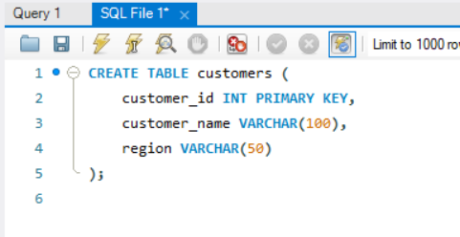
inserting in customers
- 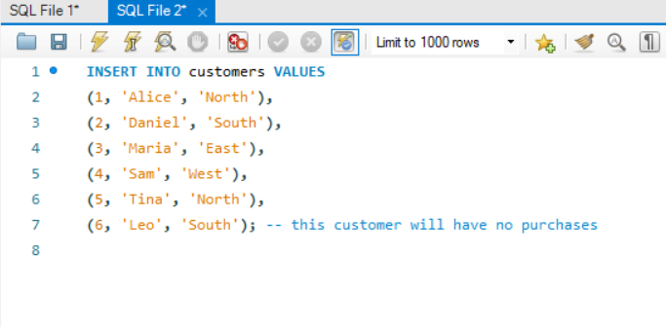
-I created products table
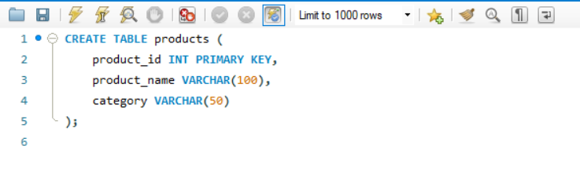
Inserting In product table
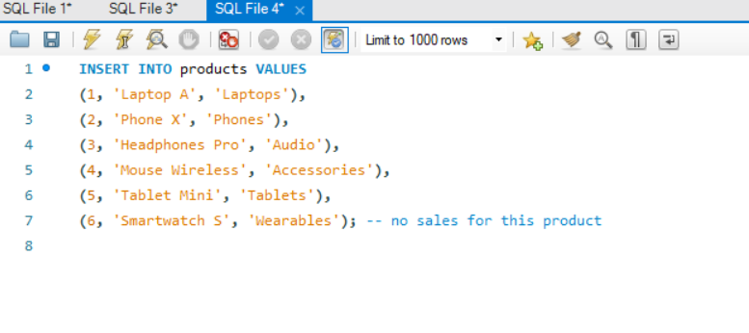
- I created sales_transactions table
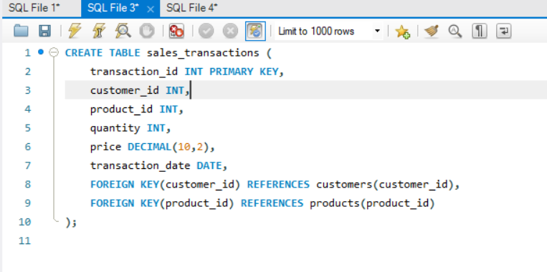

Inserting in sales_transactions table
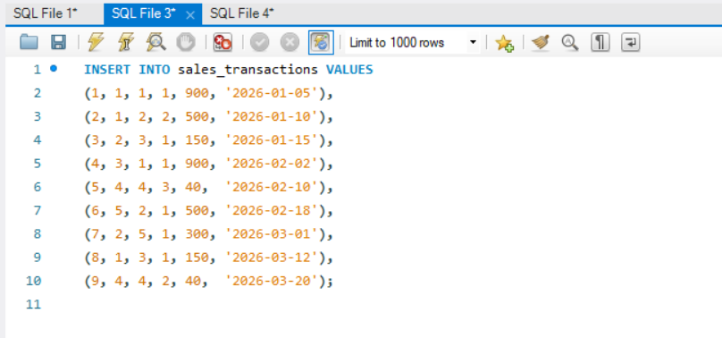
My ER Diagram
This Entity Relationship Diagram (ERD) models a sales system involving customers, products, and transactions.

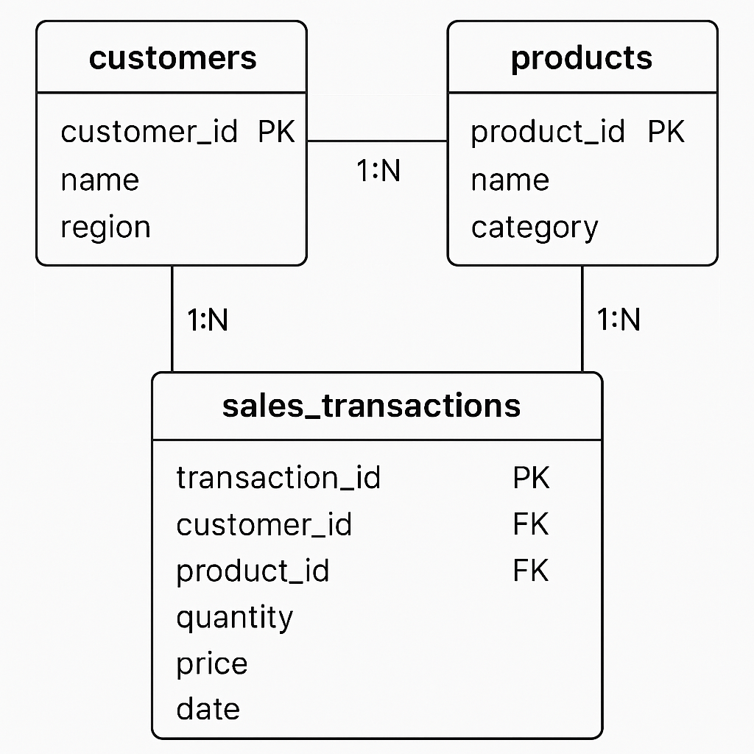

3. SQL JOIN Queries

3.1 INNER JOIN – Transactions with Valid Customers and Products
The INNER JOIN returns only transactions that match both customers and products.
SELECT
st.transaction_id,
c.customer_name,
p.product_name,
st.quantity,
st.price
FROM sales_transactions st
INNER JOIN customers c ON st.customer_id = c.customer_id
INNER JOIN products p ON st.product_id = p.product_id;
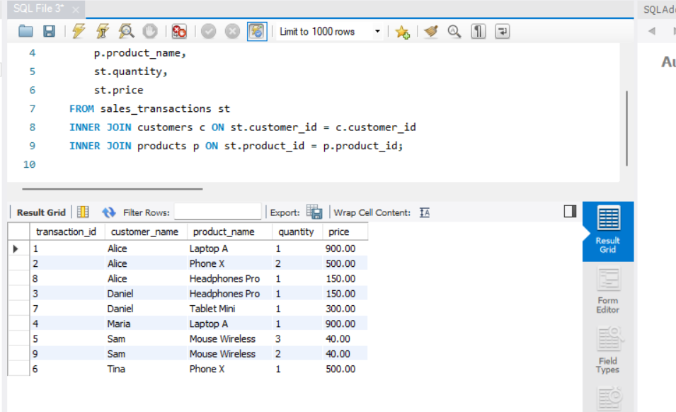
This query shows valid purchases made by real customers for actual products. It helps verify clean data and understand normal business transaction activity.

3.2 LEFT JOIN – Customers with No Transactions
The LEFT JOIN retrieves all customers, including those who never made a purchase.
SELECT
c.customer_name,
st.transaction_id
FROM customers c
LEFT JOIN sales_transactions st
ON c.customer_id = st.customer_id;
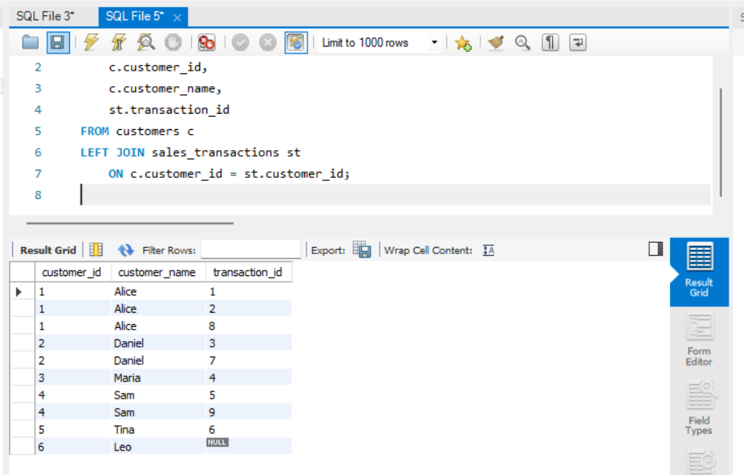
This helps identify inactive customers. A business could target these customers with promotions or follow‑up campaigns.

3.3 FULL OUTER JOIN Simulation Products With or Without Sales
Because MySQL does not support FULL OUTER JOIN, a UNION of LEFT and RIGHT JOIN is used.
SELECT
p.product_name,
st.transaction_id
FROM products p
LEFT JOIN sales_transactions st ON p.product_id = st.product_id
UNION
SELECT
p.product_name,
st.transaction_id
FROM products p
RIGHT JOIN sales_transactions st ON p.product_id = st.product_id;
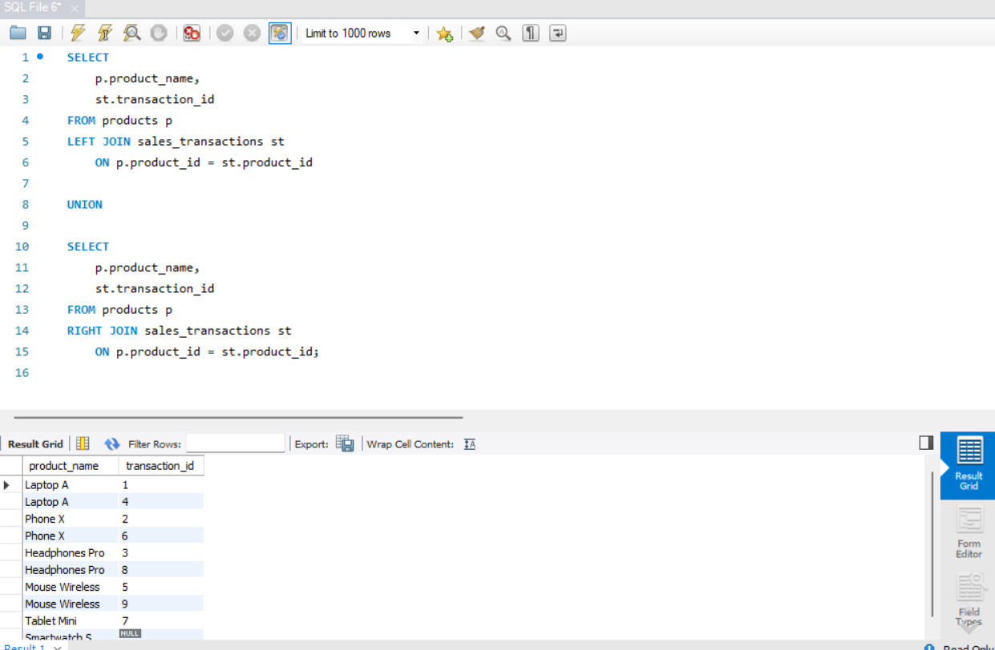
This includes all products whether sold or not, and all transactions whether they match a product or not. This helps detect missing or incorrect product links.

3.4 SELF JOIN – Customers in the Same Region
A SELF JOIN is used to compare rows within the same table.
SELECT
c1.customer_name AS customerA,
c2.customer_name AS customerB,
c1.region
FROM customers c1
JOIN customers c2
ON c1.region = c2.region
AND c1.customer_id <> c2.customer_id;
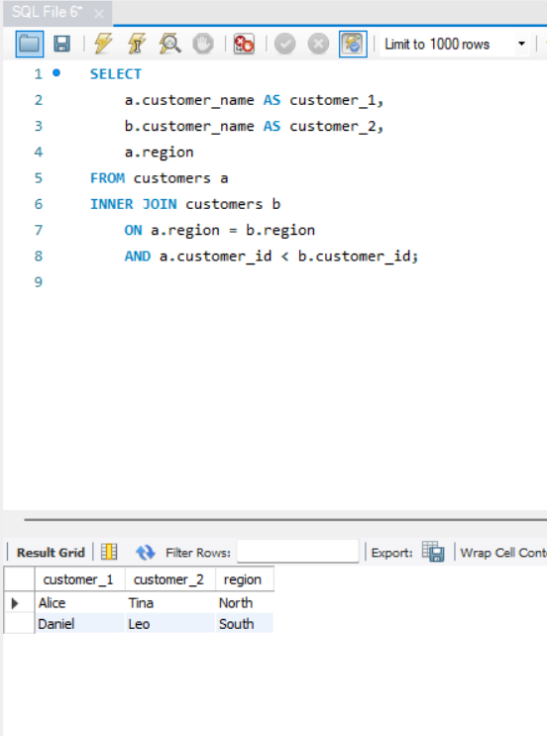
This identifies customers who live in the same region. Useful for regional marketing or grouping customers by location.

4. Window Function Queries

4.1 Ranking Functions Top Selling Products
SELECT
p.product_name,
SUM(st.quantity * st.price) AS total_sales,
RANK() OVER (ORDER BY SUM(st.quantity * st.price) DESC) AS ranking
FROM sales_transactions st
JOIN products p ON st.product_id = p.product_id
GROUP BY p.product_id;
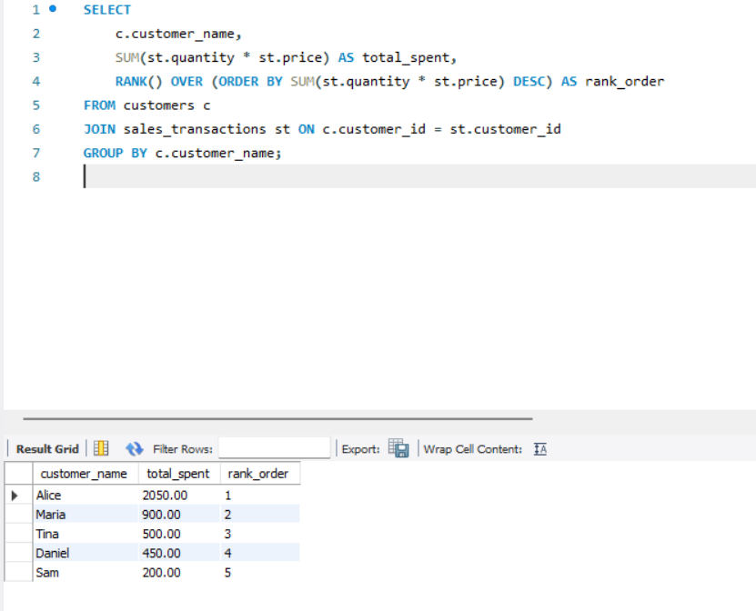 This ranks products by total revenue. It helps identify best-performing products.

4.2 Aggregate Window Functions Running Sales Totals
SELECT
transaction_date,
quantity * price AS sales_amount,
SUM(quantity * price) OVER (ORDER BY transaction_date) AS running_total
FROM sales_transactions;
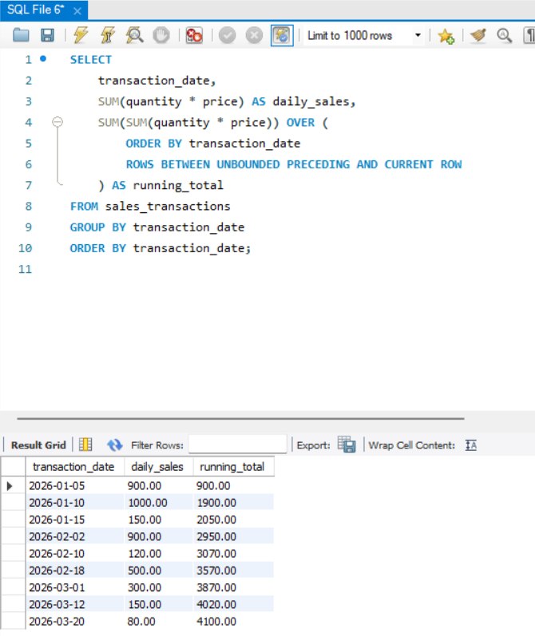
This shows cumulative revenue over time and helps identify growth patterns.

4.3 Navigation Functions Month-to-Month Comparison
This is the MySQL queries I used:
WITH monthly_sales AS (
SELECT
DATE_FORMAT(transaction_date, '%Y-%m-01') AS month,
SUM(quantity * price) AS monthly_total
FROM sales_transactions
GROUP BY DATE_FORMAT(transaction_date, '%Y-%m-01')
)
SELECT
month,
monthly_total,
LAG(monthly_total) OVER (ORDER BY month) AS previous_month,
monthly_total - LAG(monthly_total) OVER (ORDER BY month) AS difference
FROM monthly_sales
ORDER BY month;
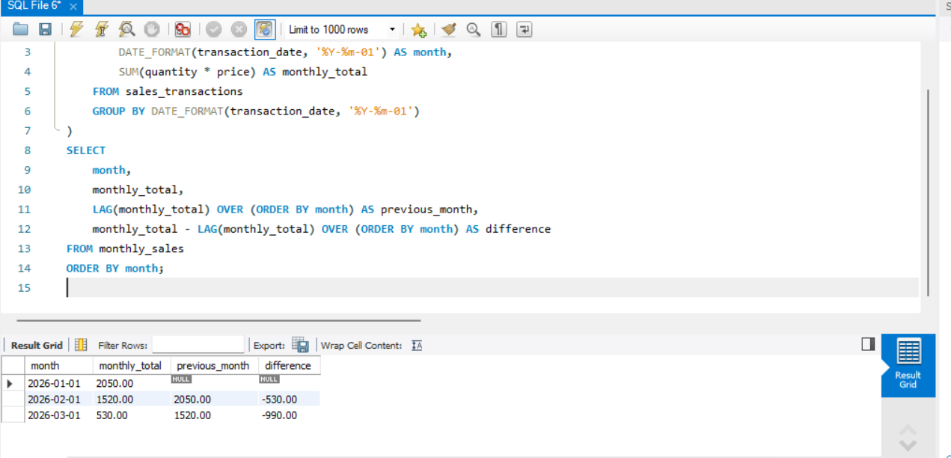
This compares each month to the previous one to show growth or decline. It helps detect seasonal patterns or sudden changes in sales.

4.4 Distribution Functions Customer Segmentation
SELECT
customer_id,
SUM(quantity * price) AS total_spent,
NTILE(4) OVER (ORDER BY SUM(quantity * price)) AS spending_quartile
FROM sales_transactions
GROUP BY customer_id;
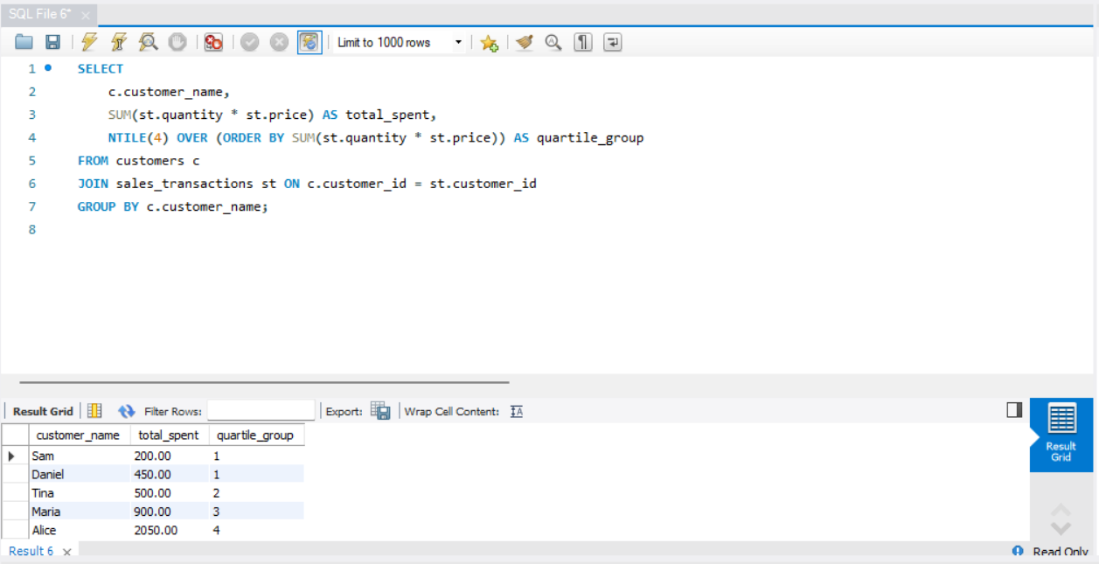
This divides customers into four spending levels. Useful for targeted marketing and loyalty programs.

5. Results Analysis

Descriptive : What Happened?
The queries revealed monthly sales totals, customer spending levels, and product performance. The JOINs showed which customers were active or inactive and which products were strong sellers.

Diagnostic :Why Did It Happen?
Changes in monthly sales may be due to seasonal demand or promotions. High-performing products likely meet customer needs, while low-performing ones may need review.

Prescriptive :What Should Be Done Next?
The business should focus marketing efforts on inactive customers, promote high-ranking products, and consider adjusting stock or pricing for items with low sales. Monthly trends can guide planning.

6. References
Integrity Statement: All queries were executed personally in MySQL Workbench and screenshots represent my own work.
- MySQL Documentation
- Course materials and personal notes
• MySQL Documentation – Window Functions
Oracle Corporation. MySQL 8.0 Reference Manual: Window Functions.
https://dev.mysql.com/doc/refman/8.0/en/window-functions.html
• MySQL Documentation – JOIN Operations
Oracle Corporation. MySQL 8.0 Reference Manual: JOIN Syntax.
https://dev.mysql.com/doc/refman/8.0/en/join.html
• W3Schools SQL Tutorial
W3Schools. SQL Tutorial and Examples.
https://www.w3schools.com/sql/
• PostgreSQL Documentation – Date/Time Functions (for comparison purposes)
PostgreSQL Global Development Group. PostgreSQL Documentation: Date/Time Functions and Operators.
https://www.postgresql.org/docs/current/functions-datetime.html
(Used to understand differences like DATE_TRUNC, which MySQL does not support.)
• Oracle Academy Learning Resources
Oracle Academy. SQL and Database Concepts Learning Material.
https://academy.oracle.com

